**EDA for Mushroom Dataset**

**Histogram**

data.hist(figsize=(20,20));

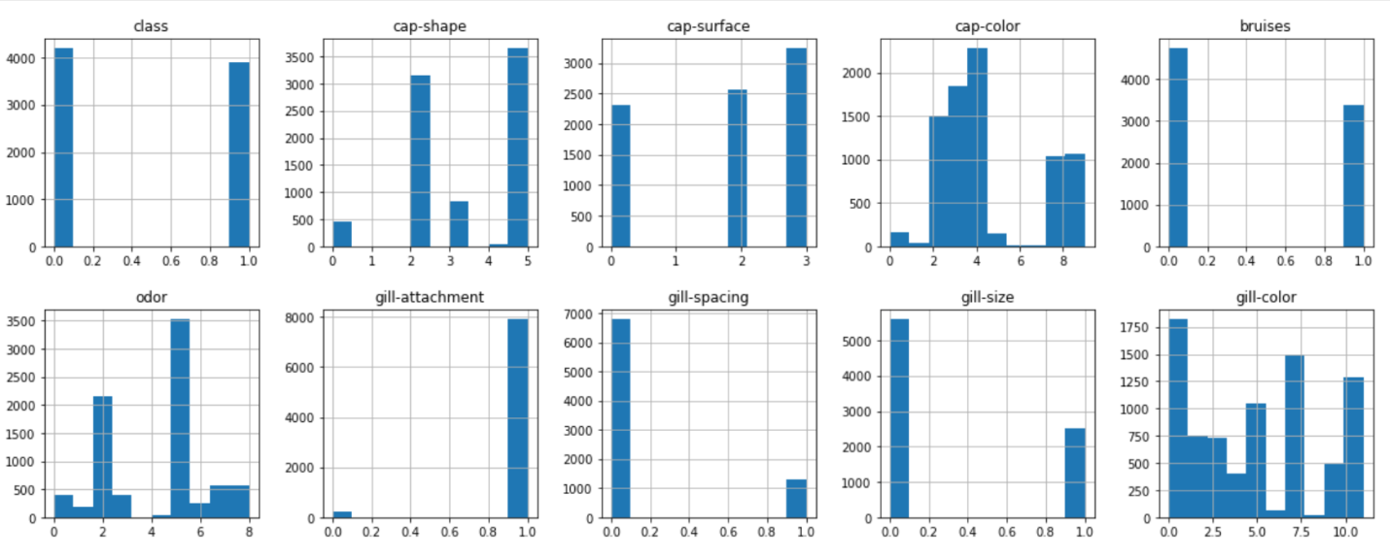

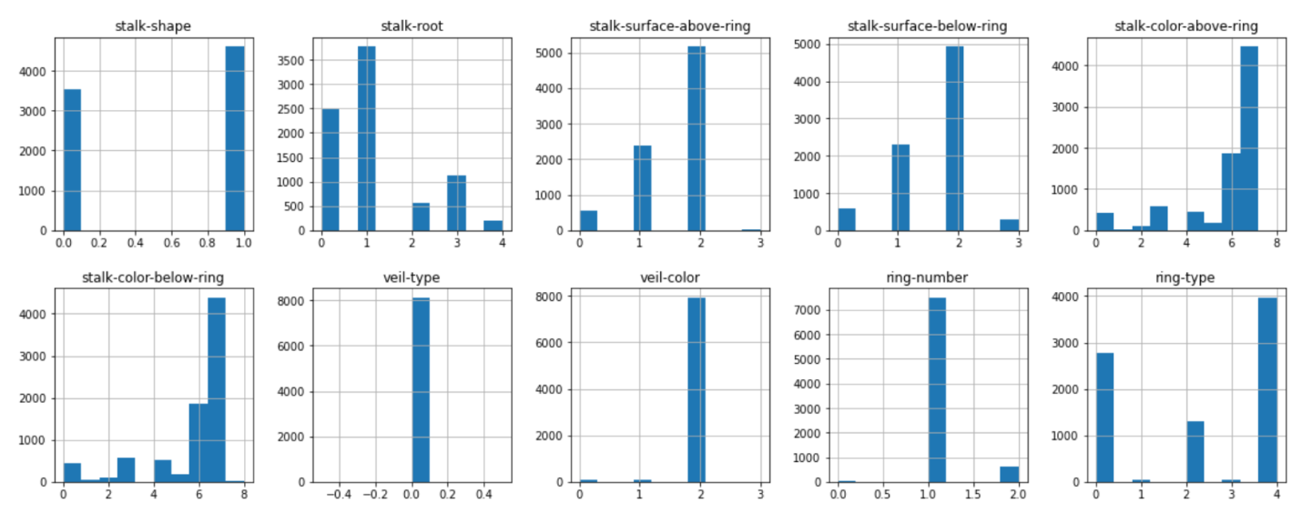

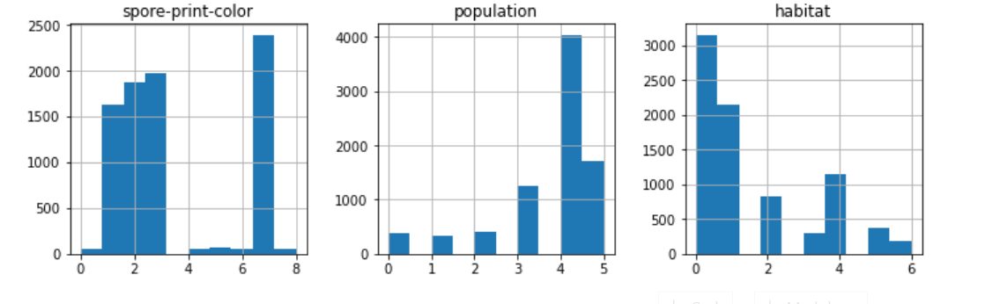

**Heatmap**

plt.figure(figsize = (20,20))

sns.heatmap(data.corr(), annot=True);

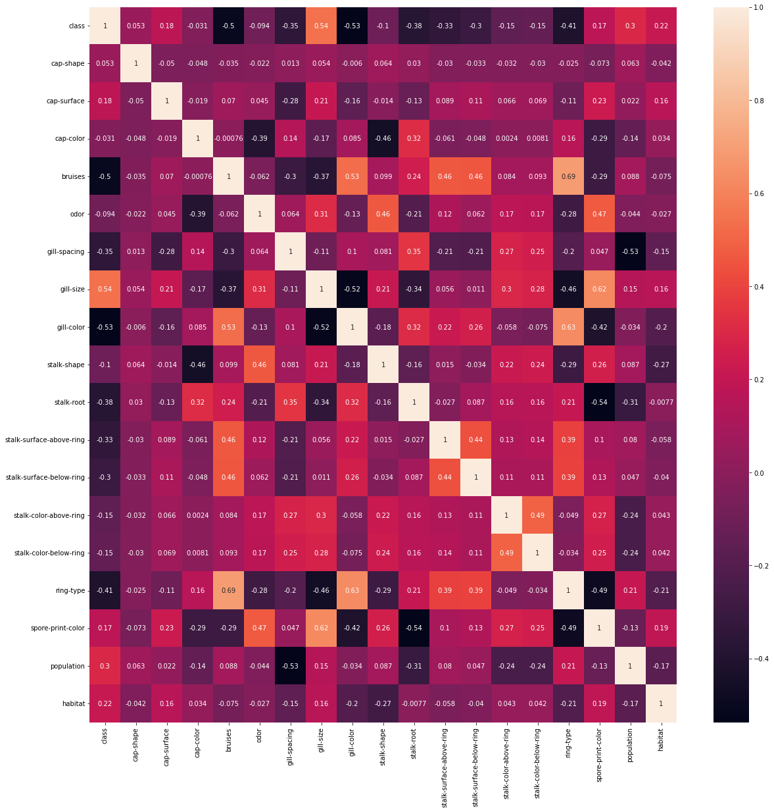

**Classification**

**Installing and Importing Libraries**

import pandas as pd

import numpy as np

import seaborn as sns

import matplotlib.pyplot as plt

**Reading Data**

DATA = pd.read_csv('../datasets/mushrooms.csv')

DATA.head()

DATA.shape

**Checking for missing values**

DATA.isna().sum().sort_values(ascending=False)

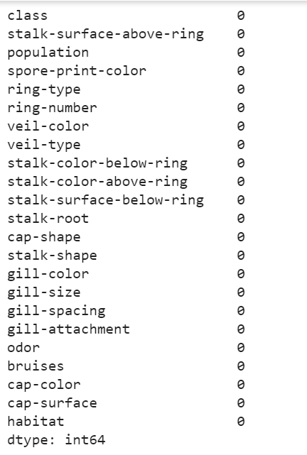

**Label Encoding**

from sklearn.preprocessing import LabelEncoder

encoder = LabelEncoder()

data = pd.DataFrame()

for col in DATA.columns:

  data[col] = encoder.fit_transform(DATA[col])

**Feature Selection**

from feature_engine.selection import SmartCorrelatedSelection, DropConstantFeatures, DropDuplicateFeatures

from sklearn.pipeline import Pipeline

pip = Pipeline([('constant', DropConstantFeatures(tol=0.9)), ('duplicate', DropDuplicateFeatures()), ('correlated', SmartCorrelatedSelection())])

data = pip.fit_transform(data)

data.shape

**ML Model**

X = data.drop('class', axis=1)

Y = data['class']

X.shape, Y.shape



from sklearn.model_selection import train_test_split

xTrain, xTest, yTrain, yTest = train_test_split(X, Y)

1. **Naïve Bayes**

from sklearn.naive_bayes import GaussianNB

nb = GaussianNB()

nb.fit(xTrain, yTrain)

print("Training Accuracy: ",nb.score(xTrain, yTrain))

print("Testing Accuracy: ",nb.score(xTest, yTest))

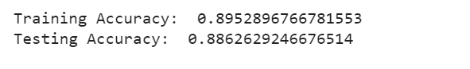

1. **KNN**

from sklearn.neighbors import KNeighborsClassifier

knn = KNeighborsClassifier(n_neighbors=1)

knn.fit(xTrain, yTrain)

yPred1 = knn.predict(xTrain)

yPred2 = knn.predict(xTest)

from sklearn.metrics import accuracy_score, confusion_matrix, classification_report

matrix = confusion_matrix(yTrain, yPred1)

print(classification_report(yTrain, yPred1))

sns.heatmap(matrix)

accuracy_score(yTrain, yPred1)

**Result 1**

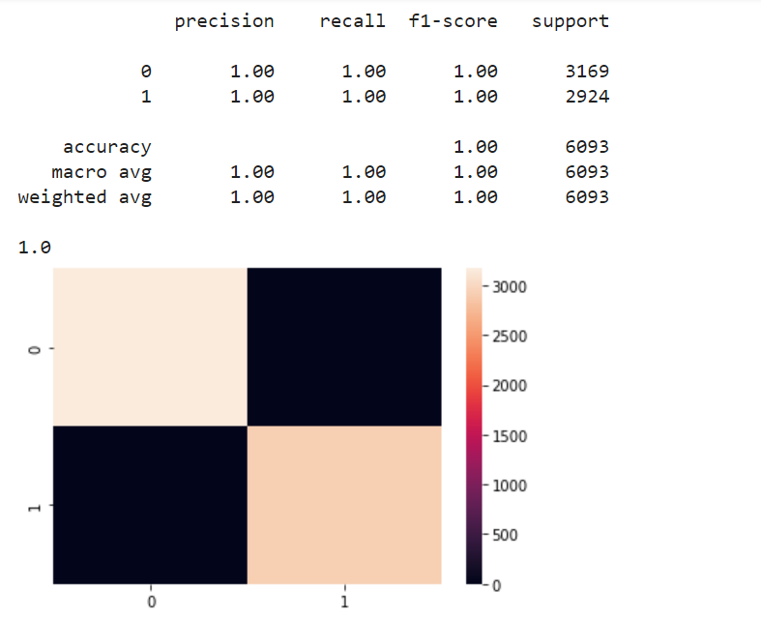

**Result 2**

matrix = confusion_matrix(yTest, yPred2)

print(classification_report(yTest, yPred2))

sns.heatmap(matrix)

accuracy_score(yTest, yPred2)

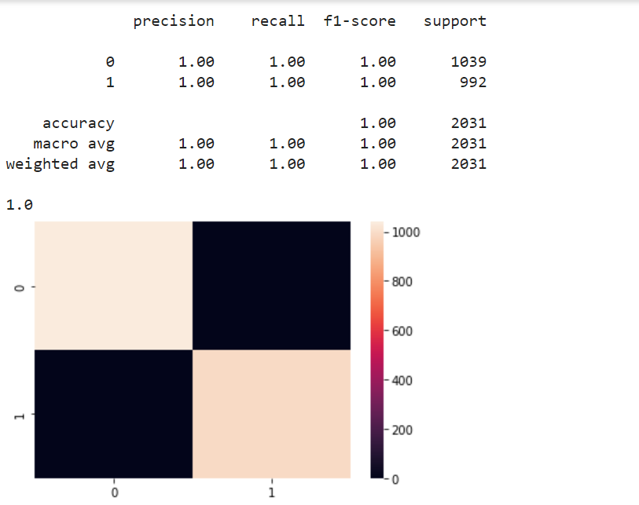

**Comparison:**

By analyzing all the steps of EDA and doing all the preprocessing, training-testing steps we can observed that both the models can predict the output with the same accuracy.

**EDA for Possum Dataset**

DATA.hist(figsize=(20,20));

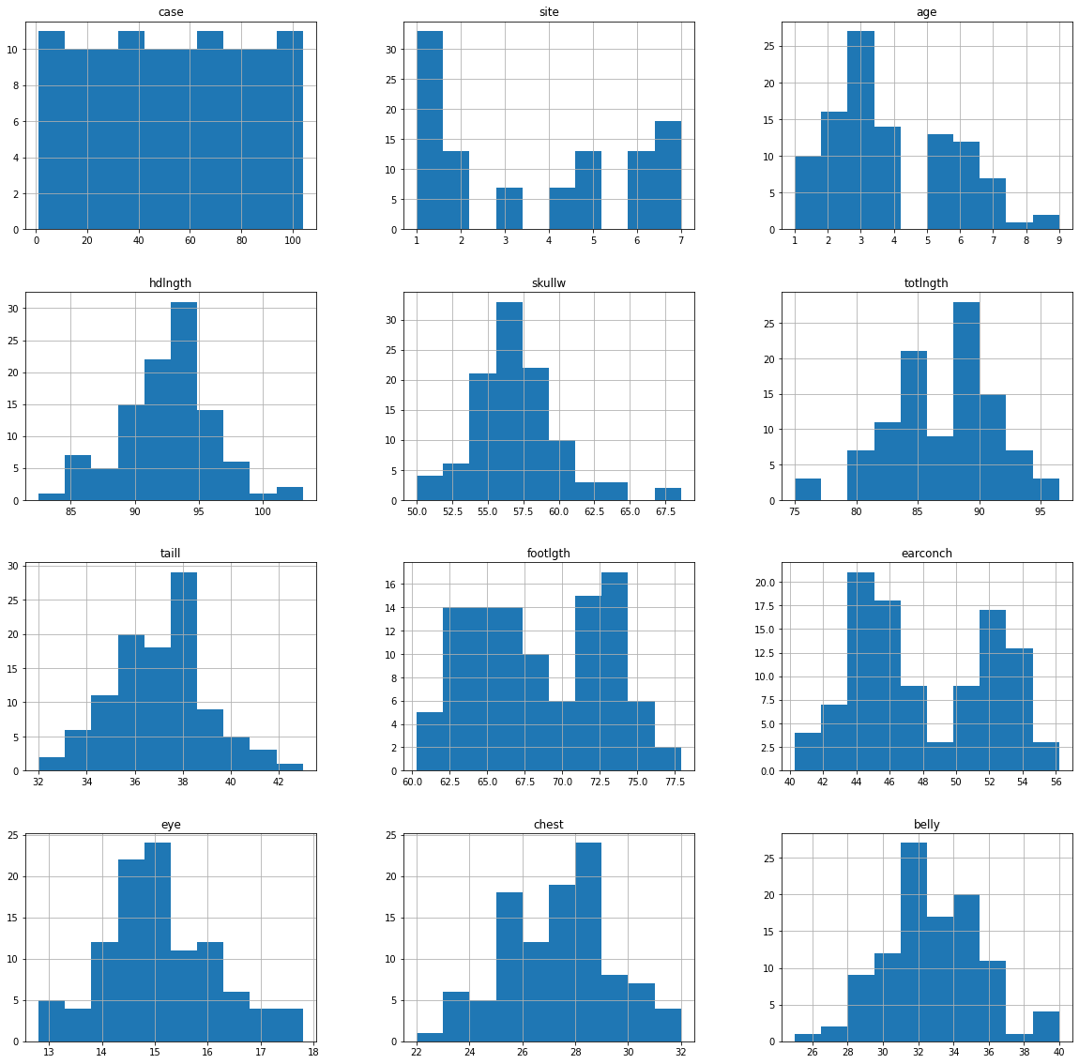

sns.pairplot(DATA,hue='age');

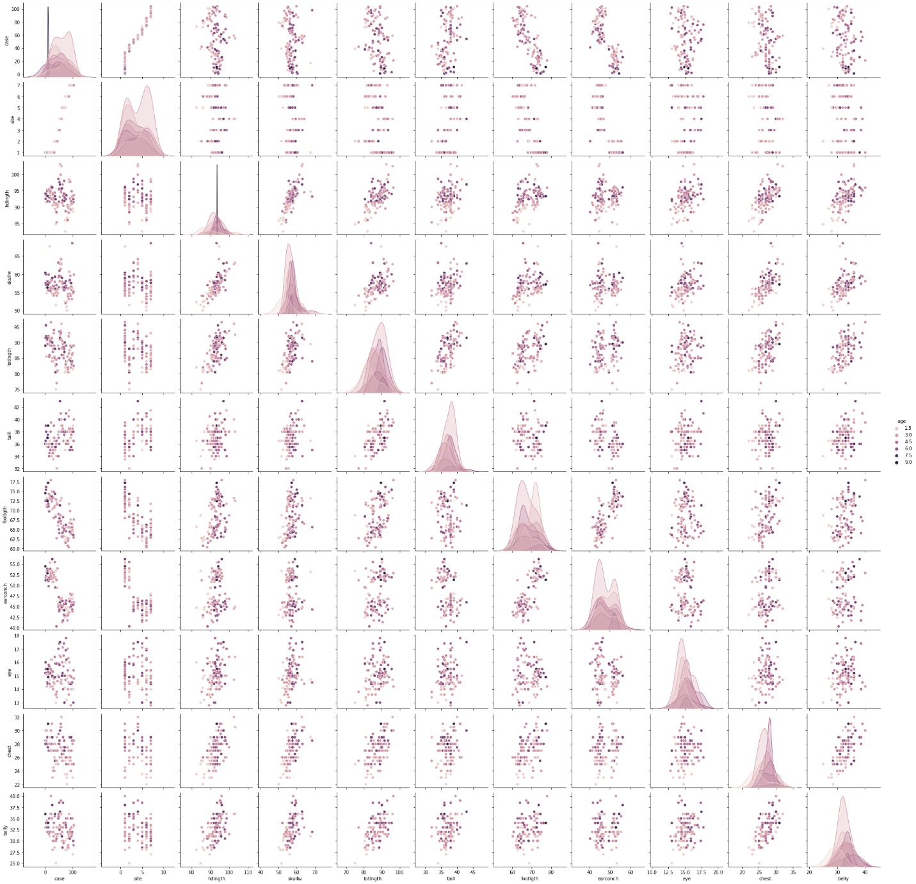

corr = DATA.corr()

plt.figure(figsize = (20,20))

sns.heatmap(corr, annot=True);

plt.title("Correlation Matrix");

plt.show()

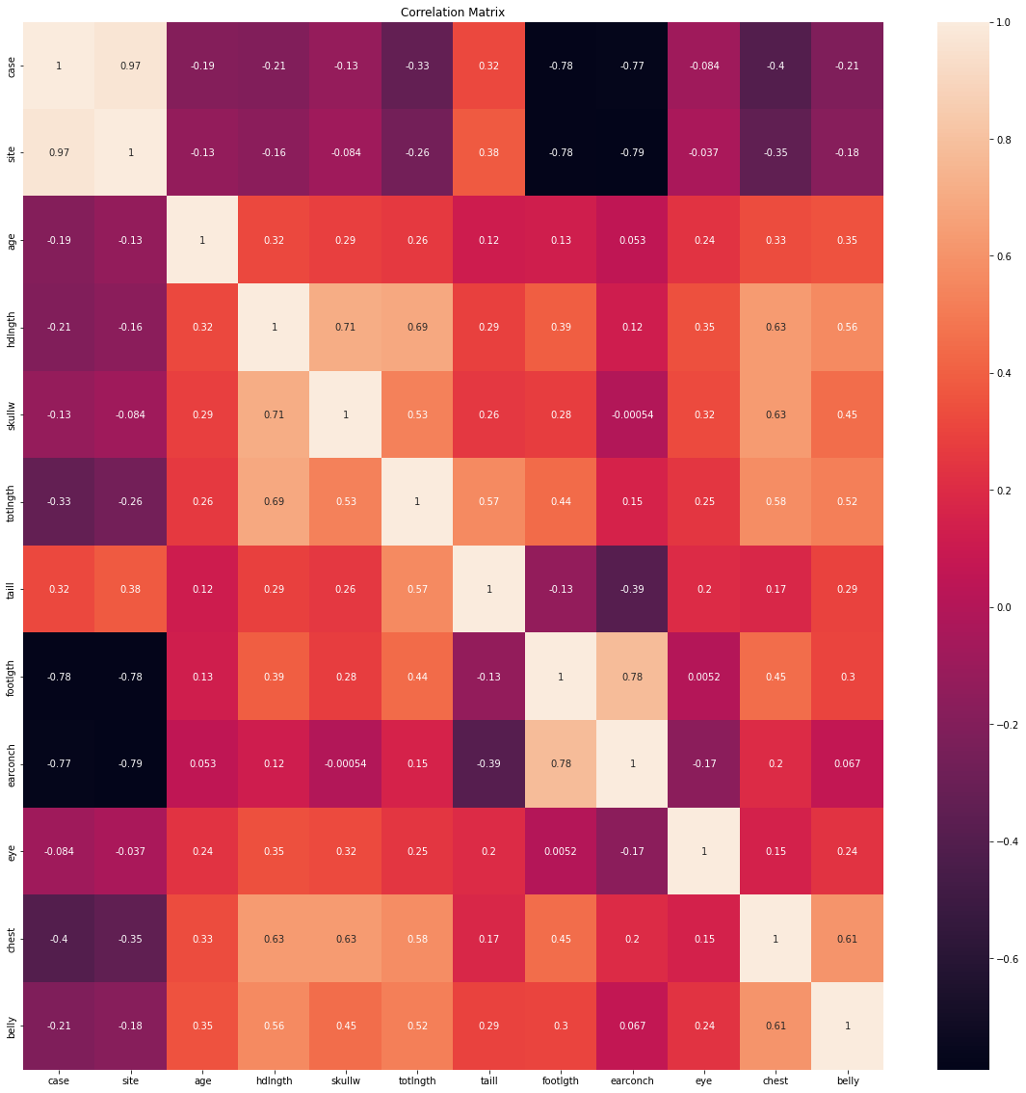

plt.scatter(DATA['hdlngth'], DATA['totlngth'])

plt.xlabel('Head Length')

plt.ylabel('Total Length')

Text(0, 0.5, 'Total Length')

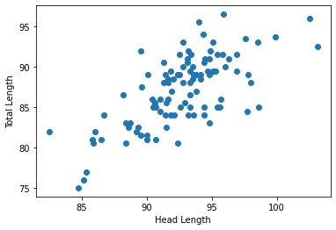

sns.boxplot(x="site", y="age", data= DATA);

plt.title("Boxplot distribution of the age of possums");

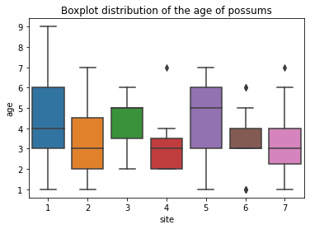

**Regression**

DATA = pd.read_csv('../datasets/possum.csv')

DATA

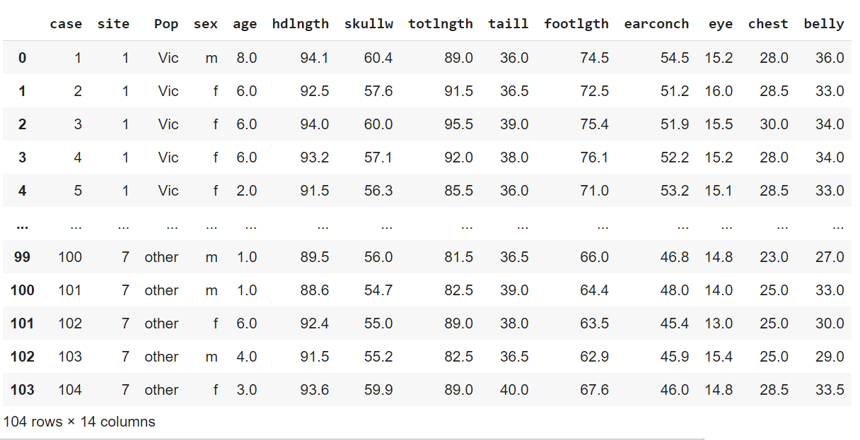

**Null Values**

DATA.isna().sum().sort_values(ascending=False)

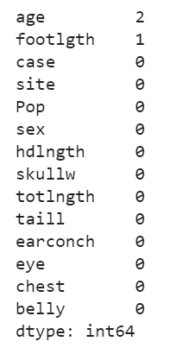

DATA['footlgth'] = DATA['footlgth'].fillna(DATA['footlgth'].mean())

DATA = DATA.dropna()

DATA.isna().any()

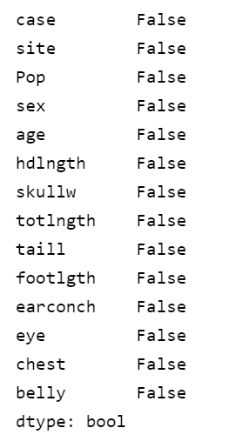

**Label Encoding**

from sklearn.preprocessing import LabelEncoder

encoder = LabelEncoder()

DATA['Pop'] = encoder.fit_transform(DATA['Pop'])

DATA['sex'] = encoder.fit_transform(DATA['sex'])

DATA.head()

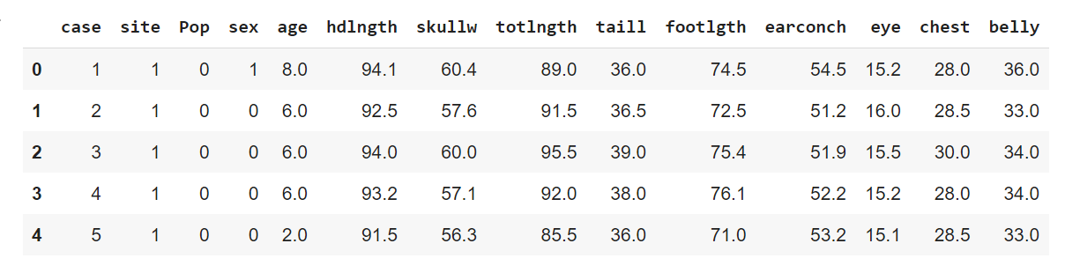

**Scaling**

DATA = DATA.drop('case', axis=1)

X = DATA.drop('age', axis=1)

Y = DATA['age']

from sklearn.preprocessing import StandardScaler

std = StandardScaler()

x = std.fit_transform(X)

**Feature Engineering**

from feature_engine.selection import SmartCorrelatedSelection, DropConstantFeatures, DropDuplicateFeatures

from sklearn.pipeline import Pipeline

pip = Pipeline([('constant', DropConstantFeatures(tol=0.9)), ('duplicate', DropDuplicateFeatures()), ('correlated', SmartCorrelatedSelection())])

x = pip.fit_transform(x)

x.shape

**Model Selection**

from sklearn.metrics import r2_score, mean_squared_error

def evaluate(y_true, y_hat, label='test'):

    mse = mean_squared_error(y_true, y_hat)

    rmse = np.sqrt(mse)

    variance = r2_score(y_true, y_hat)

    print('{} set RMSE:{}, R2:{}'.format(label, rmse, variance))

from sklearn.model_selection import train_test_split

xTrain, xTest, yTrain, yTest = train_test_split(x, Y)

1. **Linear Regression**

from sklearn.linear_model import LinearRegression

model = LinearRegression()

model.fit(xTrain, yTrain)

y_hat_train = model.predict(xTrain)

evaluate(yTrain, y_hat_train)

**Result**

y_hat_test = model.predict(xTest)

evaluate(yTest, y_hat_test)

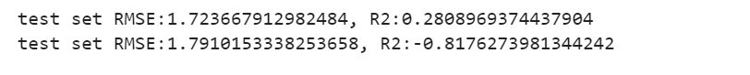

1. **SVM**

from sklearn.svm import SVR

svr_f = SVR()

svr_f.fit(xTrain, yTrain)

y_hat_train = svr_f.predict(xTrain)

evaluate(yTrain, y_hat_train, 'train')

**Result**

y_hat_test = svr_f.predict(xTest)

evaluate(yTest, y_hat_test)

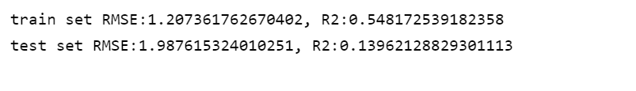

**Comparison:**

It can be observed that both the models can predict the output with high accuracy, but the Linear Regression model produces a bit more error than the SVM model. Hence, SVM has better accuracy.